Greening the OR

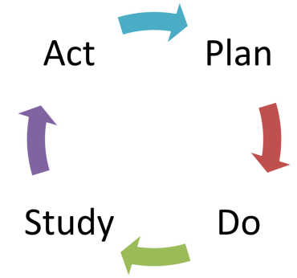

  - The goal of this assignment is to work through the initial steps of creating, a solution to a problem using the Plan, Do, Study, Act (PDSA) quality improvement cycle. Although you wont have the opportunity to implement and evaluate through this assignment, it might be something you want to try out once you are working in the OR!
  - For the purposes of this assignment, you have already identified the problem. The Perioperative environment does not have any form of recycling program at all. Everything goes into the garbage.
  - The following activities and questions will help guide you through the steps to develop a plan for change. Work through the steps below. When you have completed your document submit for grading.

Pre-Planning

Define the Problem
- Describe a problem you see in your clinical area using the 5 W’s. | /5
What is the problem?
Who is impacted by this problem?
Why is this a problem?
When did this problem start?
Where does the problem occur?

- Identify three potential explanations for why this problem may be occurring. You can be a bit creative here since you don’t have the ability to observe this OR or ask colleagues questions. | /1.5

1. | 2. | 3.

- For one of the three explanations above find the Root Cause of the problem. Ask yourself “Why did that happen?” five times to understand what factors are really creating the problem. Again be creative here as long as you are coming up with plausible reasons! | /2

Chosen Explanation 1.1c:

Why?
Why?
Why?
Why?
Why?

Brainstorm Solutions
- Consider the different factors identified by the 5 Why’s and brainstorm five possible solutions for your problem. At this moment, consider ANY possible solutions and don’t worry about how ‘out of this world’ or unrealistic they might be, you will have the opportunity to assess that on the next step! : |  |  | /2.5
 | 1
 | 2
 | 3
 | 4
 | 5

- Consider your possible solutions using the P.I.C.K. (Possible, Implement, Challenge, Kibosh (discard the idea)) Chart below. Use the chart to categorize the solutions you brainstormed according to degree of impact and effort required considering: | /2
  - To what degree can you impact the area/system in question?
  - How much effort will be required to impact the area/system in question?

P.I.C.K. Chart
Low IMPACT |  | High IMPACT
Easy to IMPELENMNT | POSSIBLE | IMPLEMENT
Hard to IMPLEMENT | KIBOSH | CHALLENGE
Definitions:
- Possible – Low Payoff, easy to do – Useful for getting some momentum behind improvements by solving some simple problems right away. The risk is also low with these ideas, so if they don’t work out, then limited effort was wasted on them.
- Implement – High Payoff, easy to do – Where most of the effort should be focused,
- Challenge – High Payoff, hard to do – Longer term projects that are good to do, but not right away, maybe only after most of the Implement projects have been resolved.
- Kibosh – Low Payoff, hard to do – These ideas should be ignored, or redefined so they can fall into one of the other three categories.
- Identify which solution you are going to work towards. Use the P.I.C.K. chart to explain why you chose this solution to focus on. |  | /3
 | SOLUTION:
 | WHY:

Set S.M.A.R.T Goals

  - After you have identified your problem and determined a potential solution as a means of addressing it, you will need to outline goals to guide the Planning phase of the PDSA cycle. Writing S.M.A.R.T. goals will help ensure you are able to evaluate whether you have achieved the results you intended to during your change implementation.
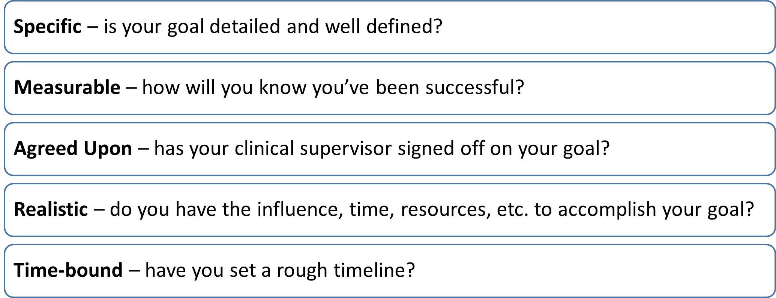

- Create S.M.A.R.T. short-term and long-term goals for the one solution you selected for your change implementation. | /4
Note: You will likely have many goals for your change implementation; choose the most meaningful and realistic of them.
Short-term
Long-term

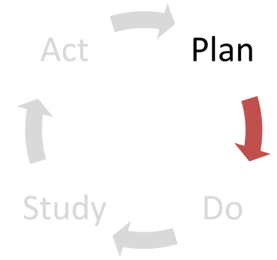
Plan

Build Your Team
- Who will you work with to make the change happen? Be thoughtful in selecting your team members by paying attention to their expertise, knowledge, skills and interest area. Do you have what it takes to achieve the goal you have created for this project? Complete the table below including all group members and additional team members such as colleagues or advisors (you will likely not know names, so just use titles ie. Nurse manager, housekeeping, Circulating nurses etc.). | /2
Name, Job Title | Expertise / Skill / Interest Area | Role on the project

Design an Intervention
- Describe in detail the intervention you will use to implement your selected solution and create change.

- Who is your primary audience? What are the relevant characteristics of this group? | /2

- What tools/methods will you use to communicate with your target audience? Justify your choice of tools. Examples: formal/informal meetings, in-services, guidelines, memos, emails, posters, newsletters, etc. |  | /2

- What is one Key Message you will deliver to create the desired change? | /2
1.

 | - Create a timeline of 5-10 key milestones to implement your solution and create change. |  | /5
Event # |  | Event Description
1
2
3
4
5
6
7
8
9
10

  - A key aspect of planning any intervention is understanding how to measure the success of your implementation. Considering your short-term goal from 1.3, consider how you might collect data to measure the success.
- What methods will you use to measure whether you reached your goal? Select one of the following: | /1

  - Audits of behaviours or compliance
  - Feedback form / Satisfaction survey
  - Focus groups to obtain ideas
  - Knowledge pre/post test
  - Sign-up forms / attendance
  - Other measure: ___________________

/33 marks

